WEEK 4: 2. Spring Rest Handson (Solutions)
Hello World RESTful Web Service
Write a REST service in the spring learn application created earlier, that returns the text "Hello World!!" using Spring Web Framework. Refer details below:
Method: GET
URL: /hello
Controller: com.cognizant.spring-learn.controller.HelloController
Method Signature: public String sayHello()
Method Implementation: return hard coded string "Hello World!!"
Sample Request: http://localhost:8083/hello
Sample Response: Hello World!!
IMPORTANT NOTE: Don't forget to include start and end log in the sayHello() method.
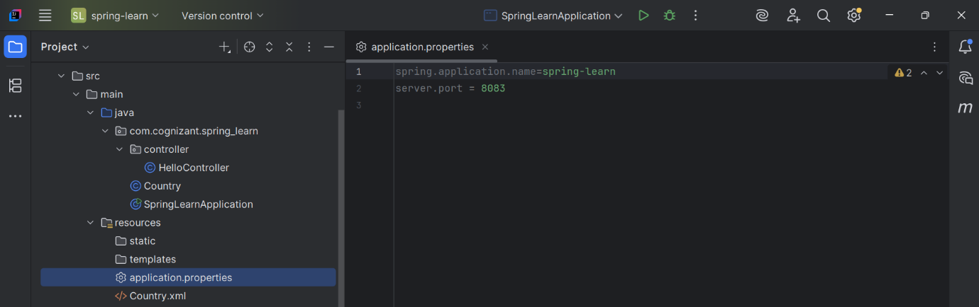

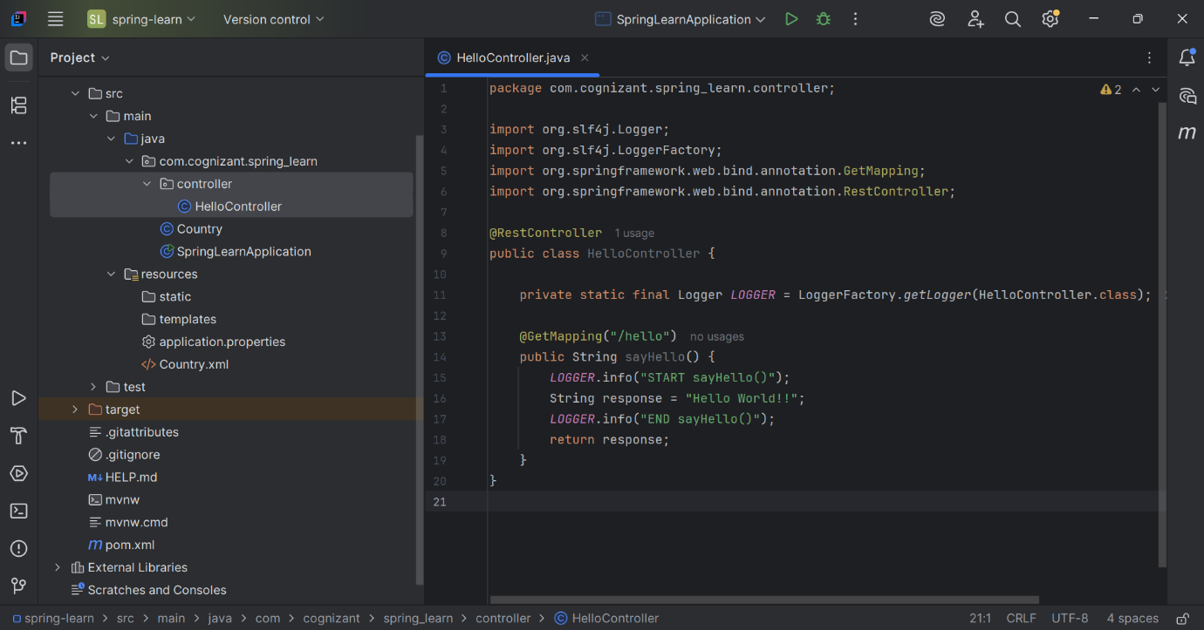
Try the URL http://localhost:8083/hello in both chrome browser and postman.

(Chrome)
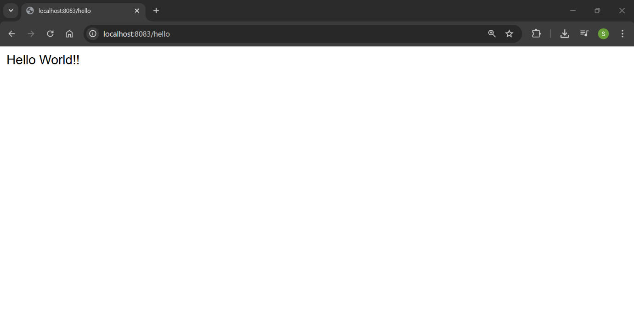

(Postman)
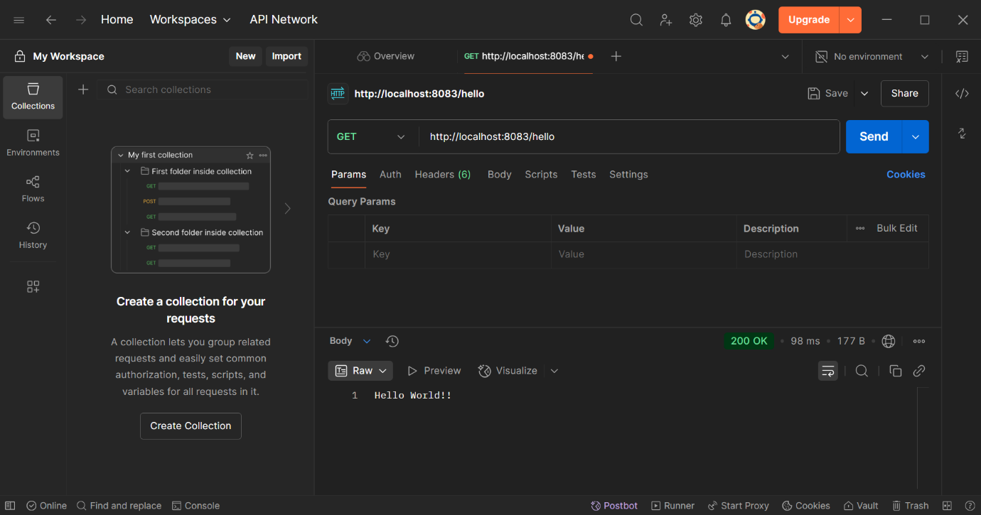

SME to explain the following aspects:
- In network tab of developer tools show the HTTP header details received

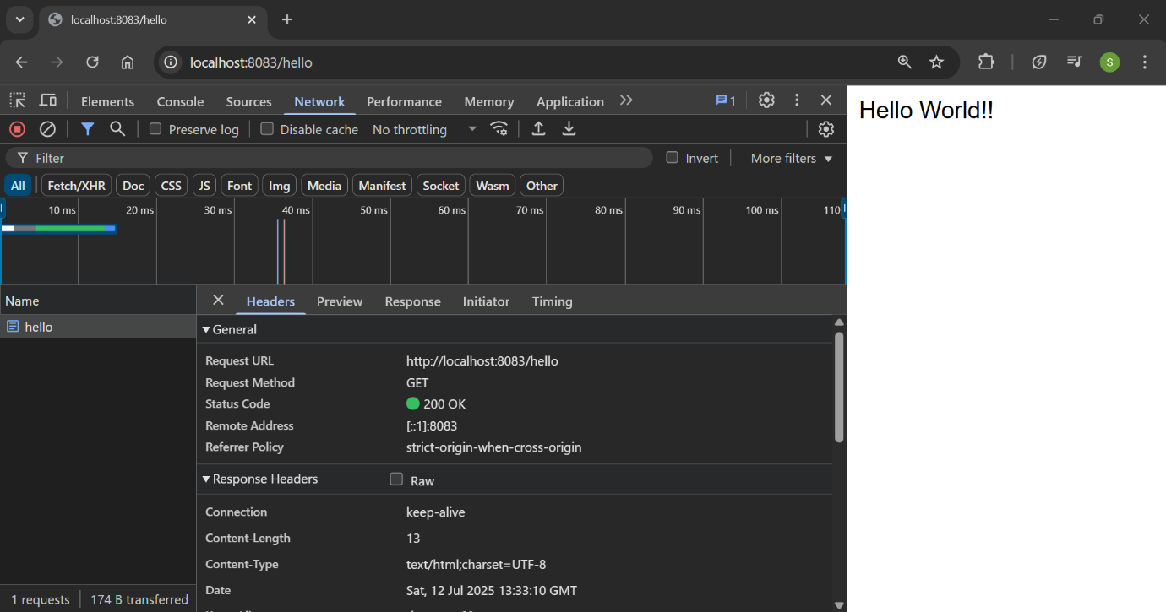

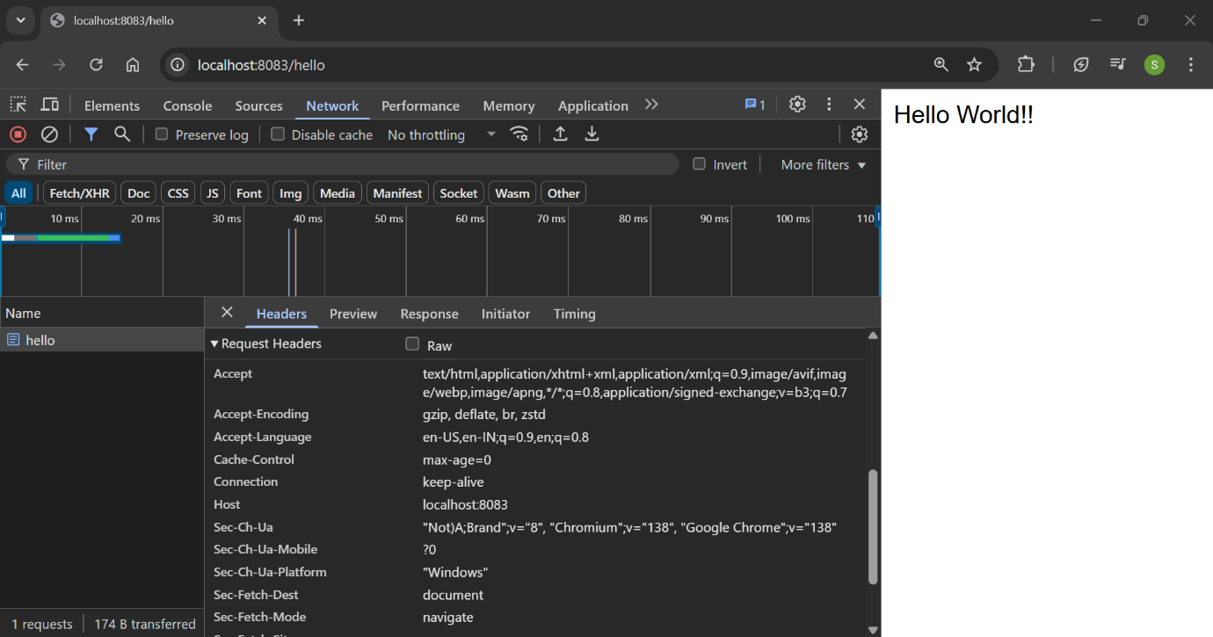

- In postman click on "Headers" tab to view the HTTP header details received
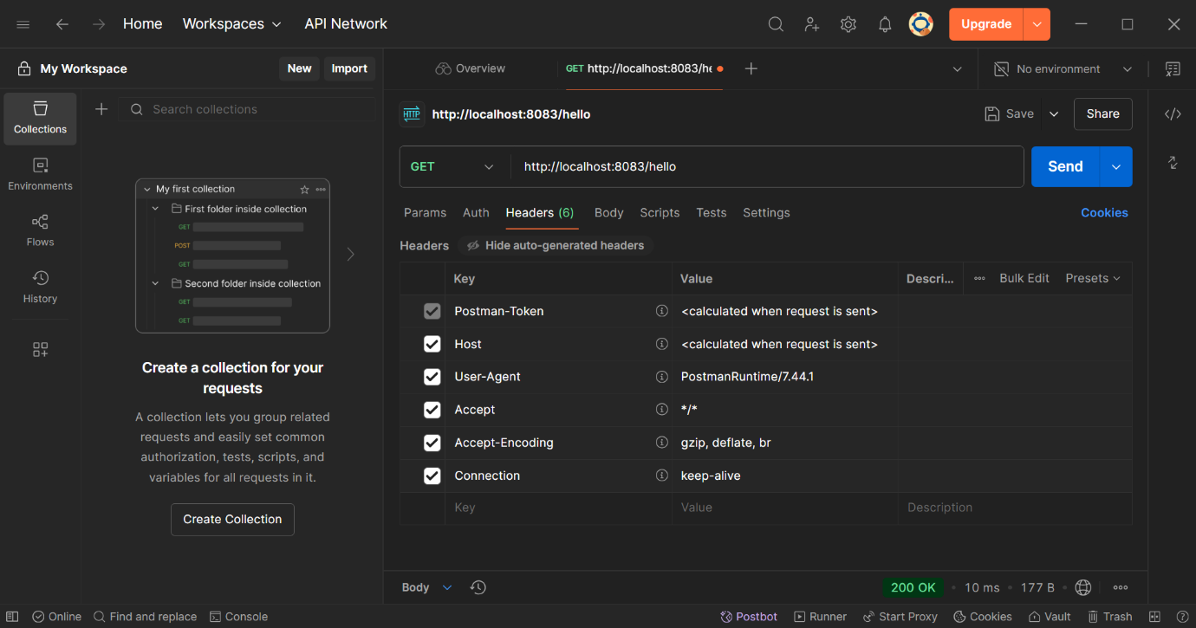

OUTPUT (console)
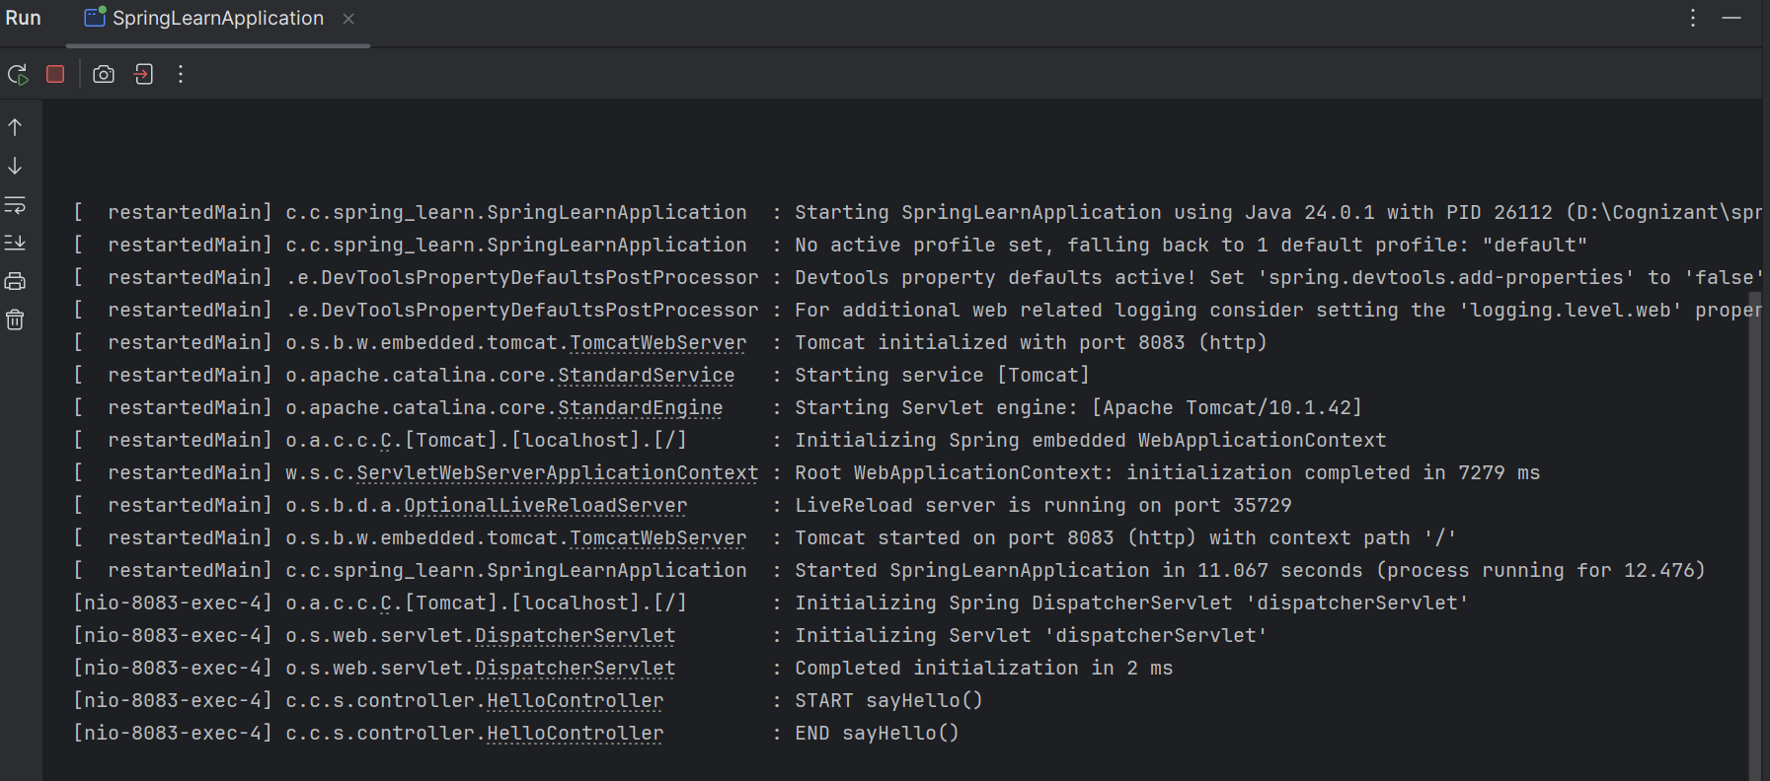

==================================================================================

REST - Country Web Service
Write a REST service that returns India country details in the earlier created spring learn application.
URL: /country
Controller: com.cognizant.spring-learn.controller.CountryController
Method Annotation: @RequestMapping
Method Name: getCountryIndia()
Method Implementation: Load India bean from spring xml configuration and return
Sample Request: http://localhost:8083/country
Sample Response:
{
"code": "IN",
"name": "India"
}

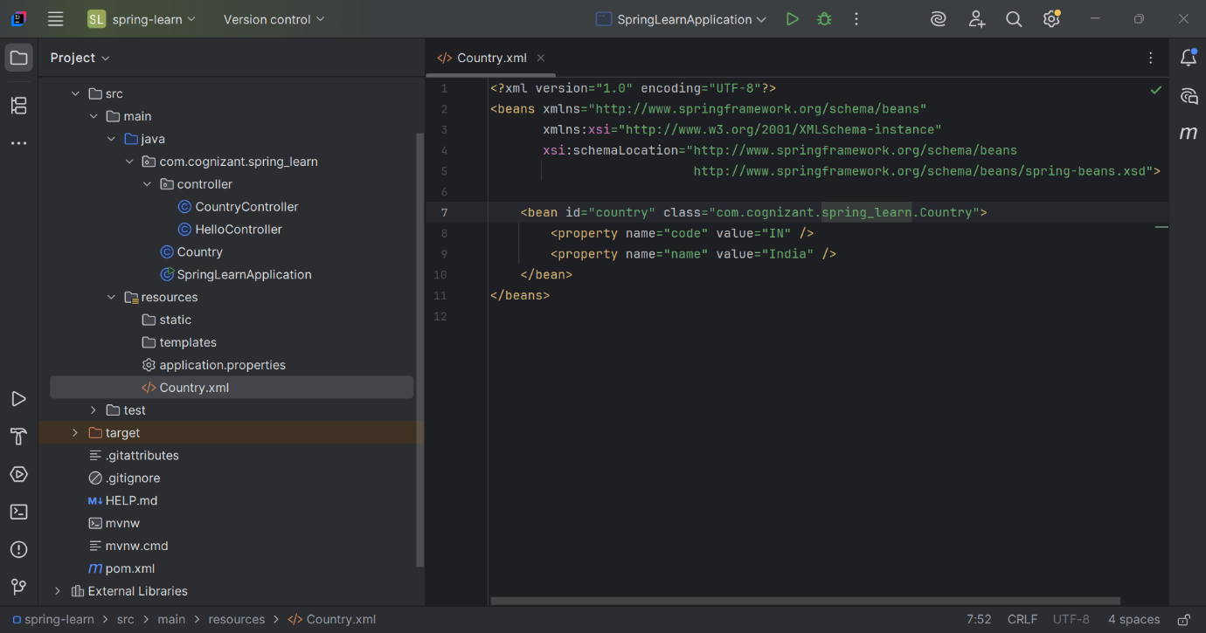

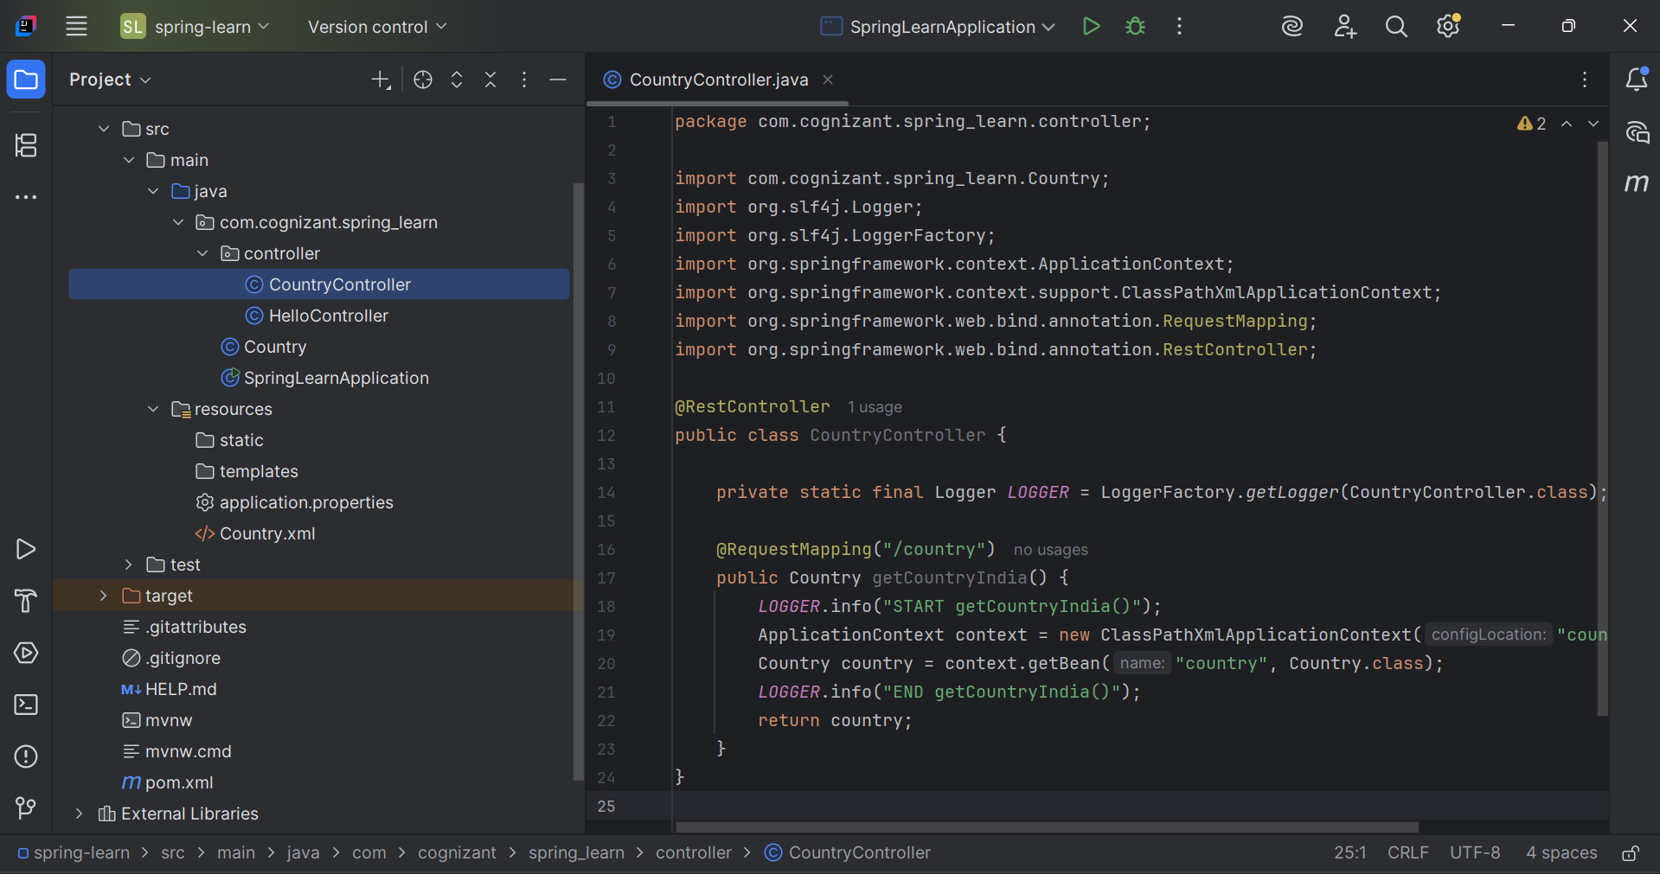

OUTPUT (Chrome):

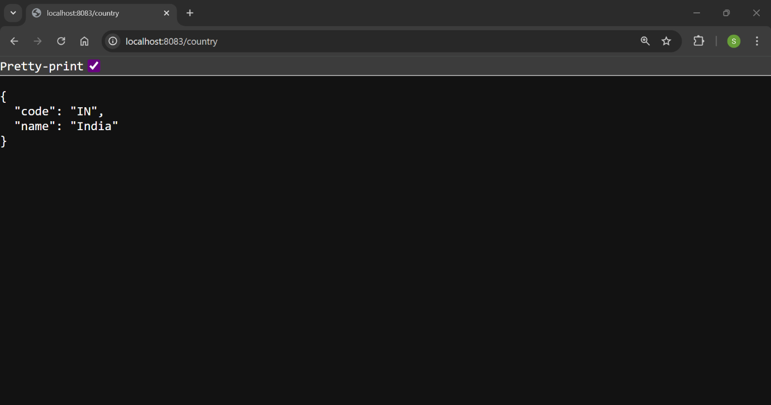

OUTPUT (Postman):

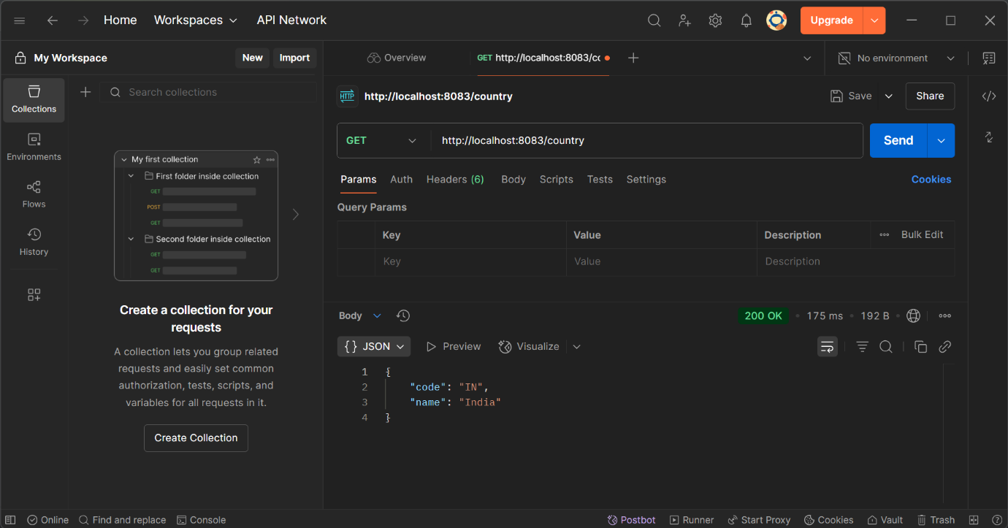

OUTPUT (console):

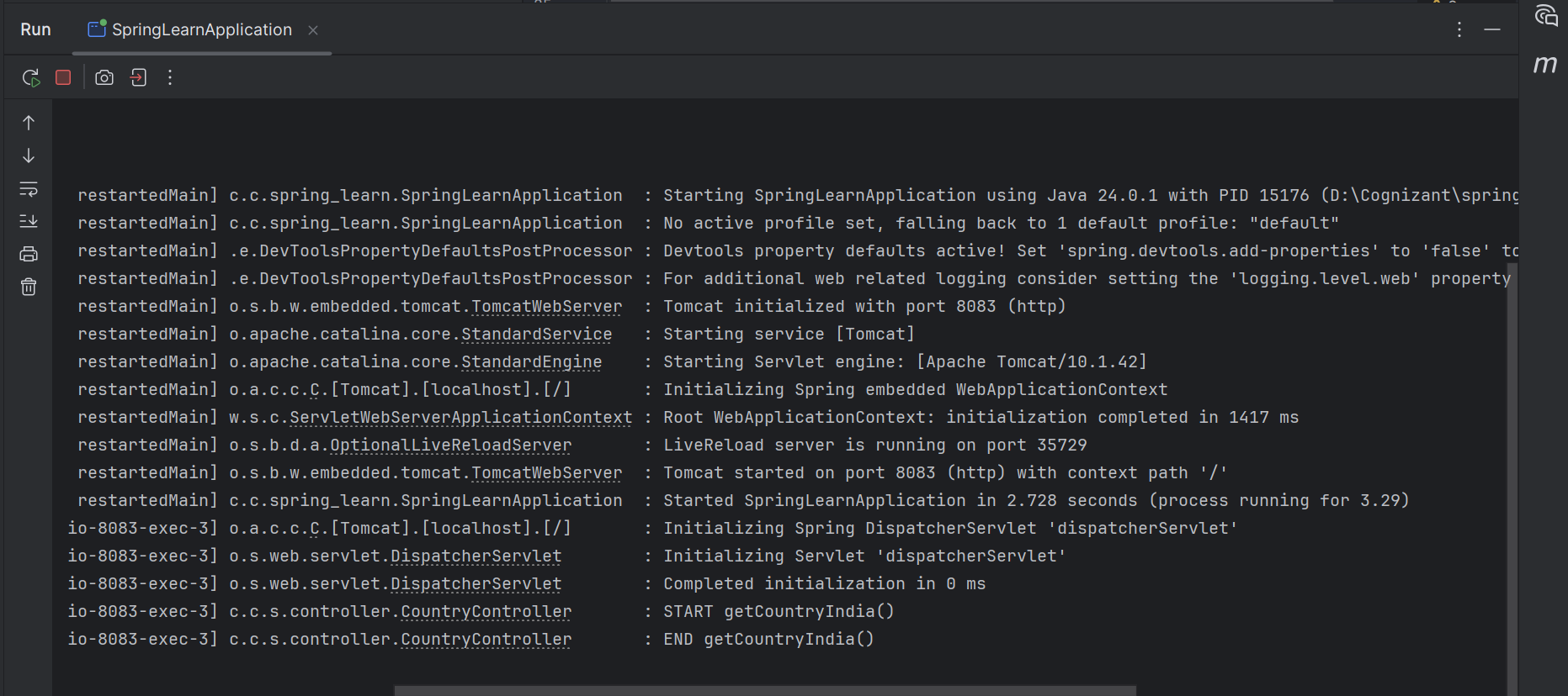

SME to explain the following aspects:
- What happens in the controller method?

- Spring calls getCountryIndia() when GET /country is requested
- ApplicationContext loads Spring XML file: country.xml
- Retrieves country bean (with code=IN, name=India)
- Returns the Country object
- Spring Boot (via Jackson) converts it to JSON automatically
- Sends it as HTTP Response Body with Content-Type application/json
- How the bean is converted into JSON reponse?

Spring Boot uses:

- Jackson (via spring-boot-starter-web)
- Detects returned object (Country)
- Serializes all public getters (getCode(), getName()) into JSON keys
- Sends result in HTTP Response body as JSON
- In network tab of developer tools show the HTTP header details received
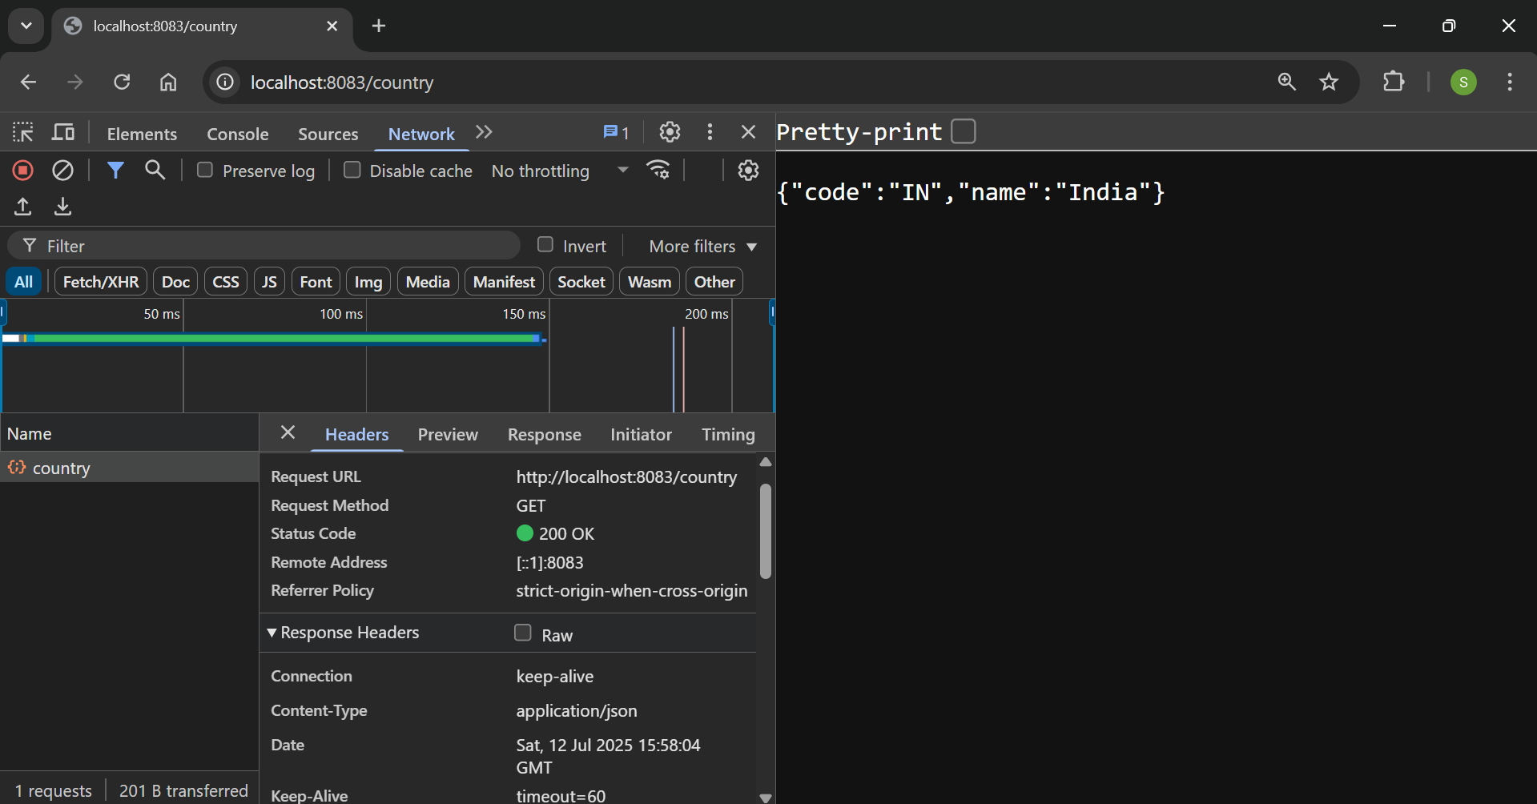

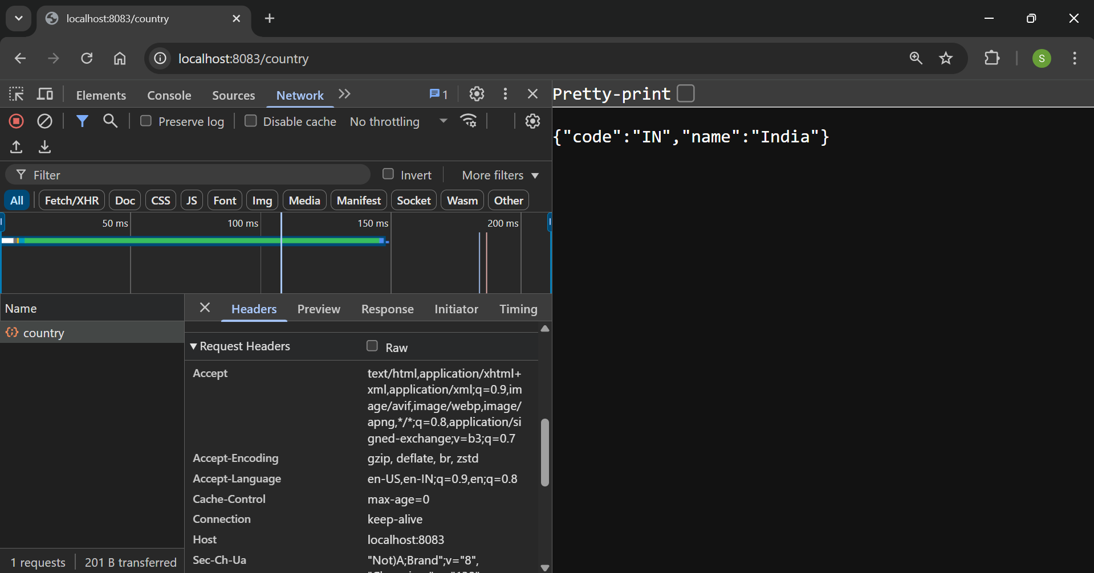

- In postman click on "Headers" tab to view the HTTP header details received
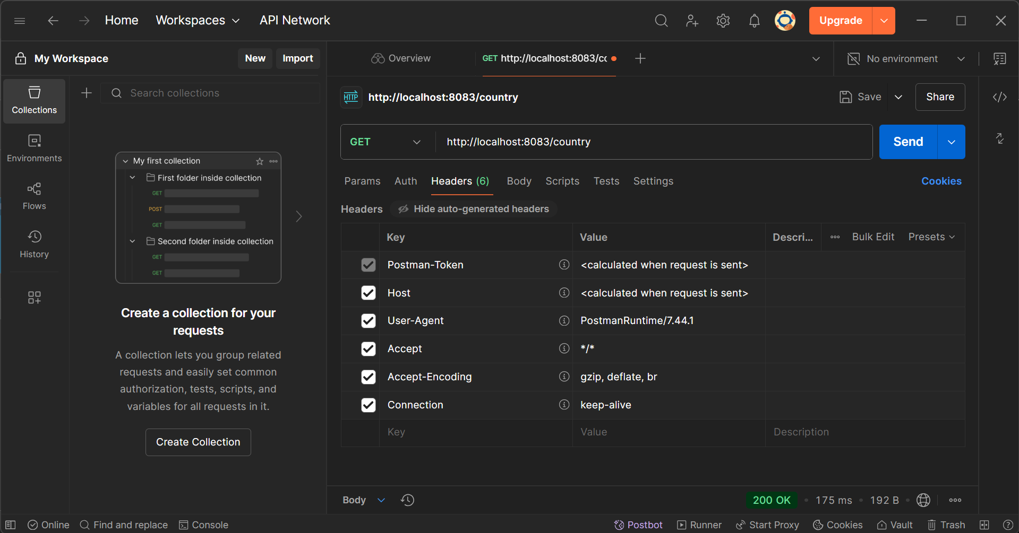

==================================================================================

REST - Get country based on country code
Write a REST service that returns a specific country based on country code. The country code should be case insensitive.
Controller: com.cognizant.spring-learn.controller.CountryController
Method Annotation: @GetMapping("/countries/{code}")
Method Name: getCountry(String code)
Method Implemetation: Invoke countryService.getCountry(code)
Service Method: com.cognizant.spring-learn.service.CountryService.getCountry(String code)
Service Method Implementation:
- Get the country code using @PathVariable
- Get country list from country.xml
- Iterate through the country list
- Make a case insensitive matching of country code and return the country.
- Lambda expression can also be used instead of iterating the country list

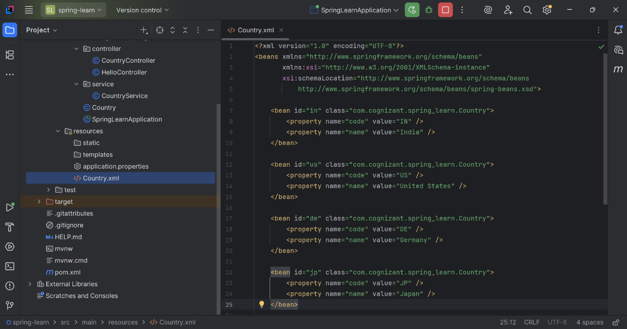

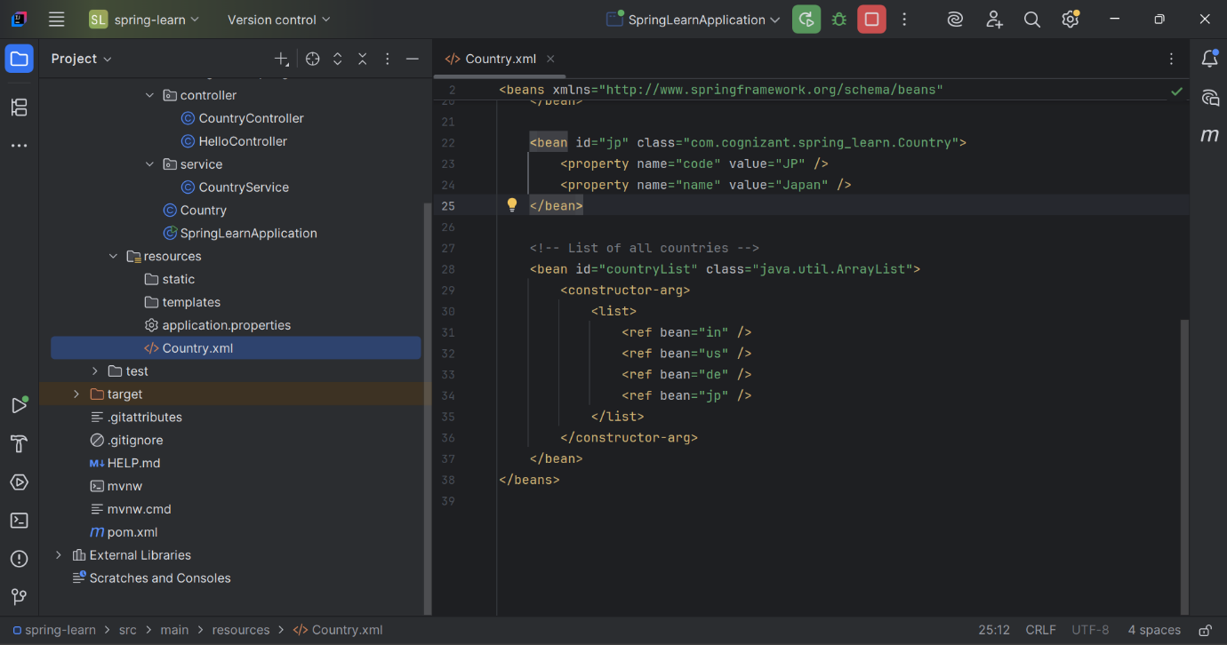

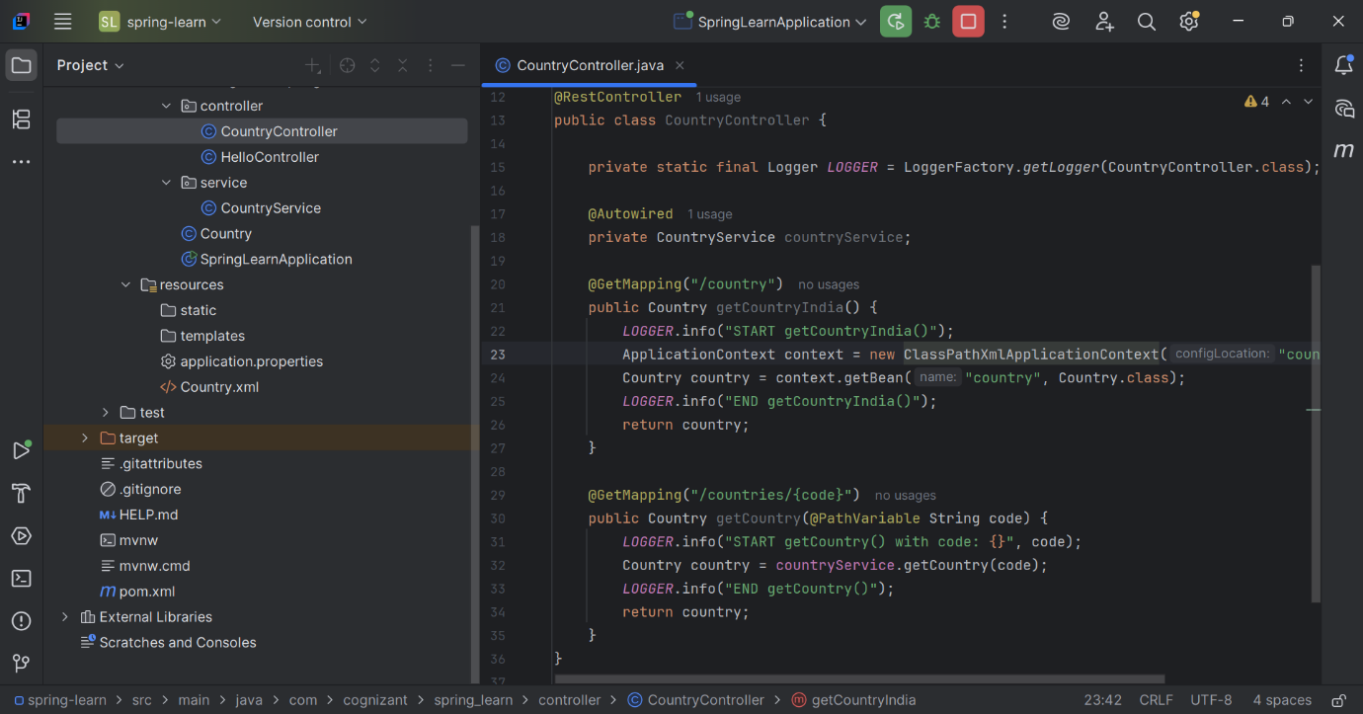

Sample Request: http://localhost:8083/country/in

Response: (Chrome)
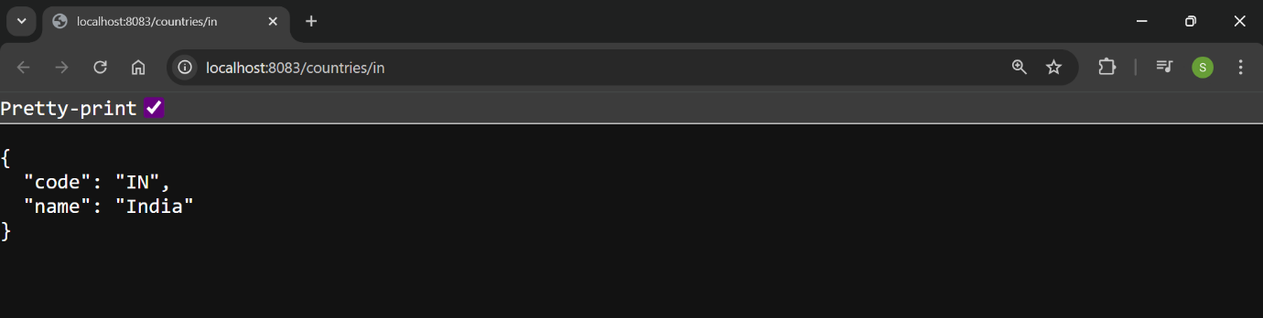

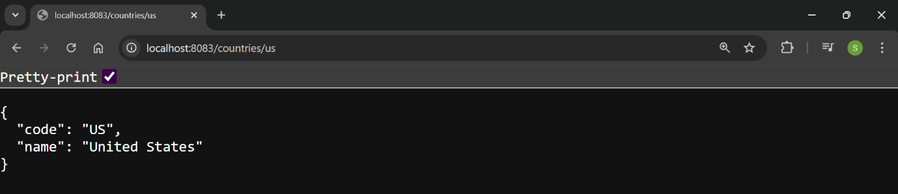

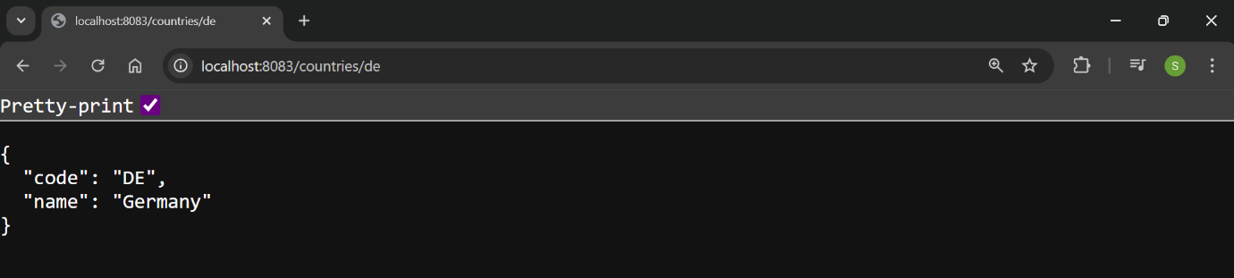

Response: (Postman)




